John Upton – The Confessions of Isobel Gowdie
Title page
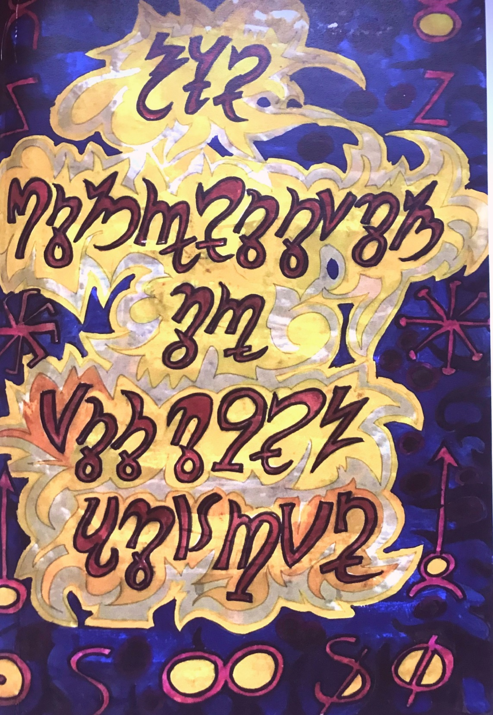
In keeping with the Gowdie theme of this conference, I am here today to say something about the artistic interpretation of Isobel Gowdie’s story by the outsider artist John Upton. But firstly, and I think more importantly, I want to tell you about the set of synchronicities and frankly, freakish coincidences that led both to the books manifestation and to them being subsequently printed by Hell Fire Club Books. For I feel it is a truly lovely example of the manifestation of real magic in this modern and often troubled world.
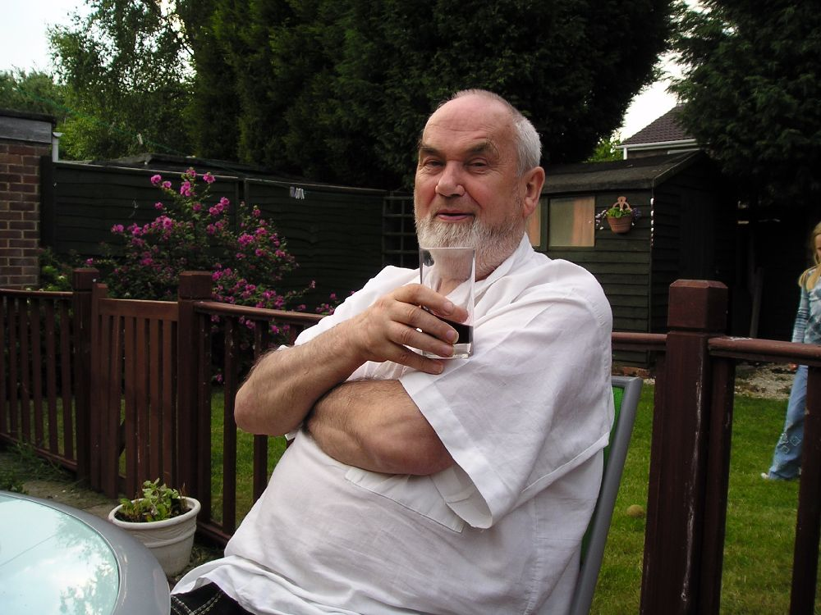
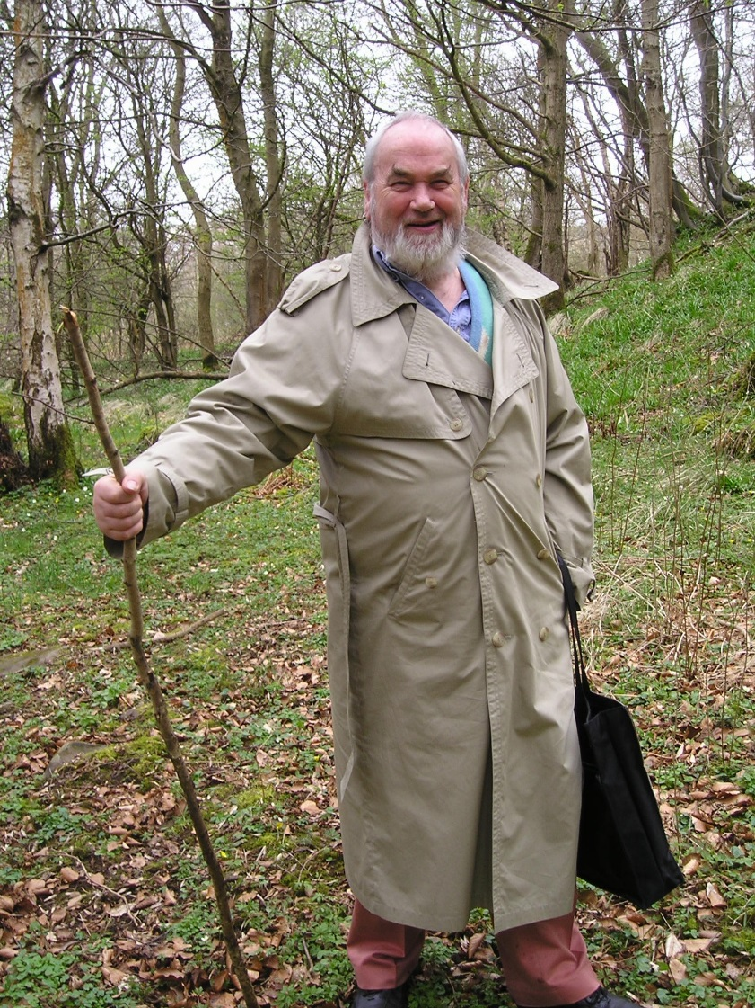
Now I’m someone who likes to paint as complete a picture as possible, I feel it’s difficult for me to tell you about how this came about, without first giving you a bit of my own background as well as that of the book’s creator, the artist John Upton.

Next slides (Mid Pennine art association circus project with 6th formers 1989)
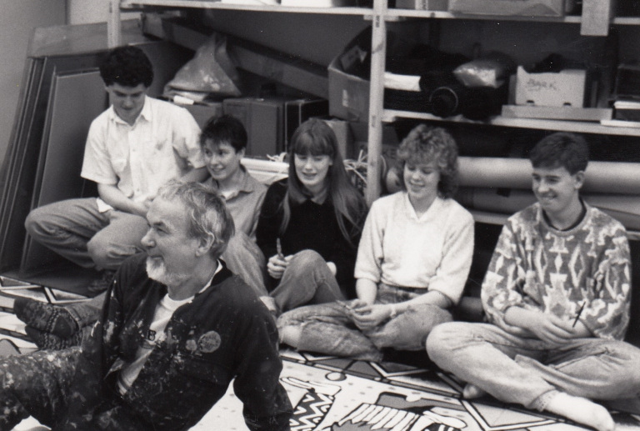
My magical journey really started as a teenager at the beginning of the 1990s, my inner calling had naturally led me towards the magical paths of Paganism and ritual magic.
Feeling somewhat isolated, I decided to start a group in Peterborough and I used to leave notes in pagan-orientated books in the library in order to make contact with people locally who had similar interests. I joined the Pagan Federation and looked for contacts in their magazine which back then was called ‘The Wiccan’. I also placed an advert in a delightful home-spun publication called ‘The Guild of Pagans’. – Does anyone remember that?
In my naivety and youthful zeal, the question of initiation quickly became my all-consuming quest. I had traipsed over to a pub moot at Cambridge a couple of times, stalked people wearing pentagrams – back then it was a rare thing to see being worn - I had also came across a traditional witchcraft group operating out of Swineshead on the Lincolnshire coast. But no invitations for initiation seemed to be happening very fast and I was very impatient!
Throughout this time, I had managed to build up a small generic Pagan and Magical group in Peterborough consisting of about half a dozen people.
One person who came to the group was a lady called Iona and to cut a long story short, by 1993 she was living in Scotland with John Upton, the artist whom created these works of art. One day, Iona wrote to me and told me that John had been initiated by Doreen Valiente.

Doreen Slide
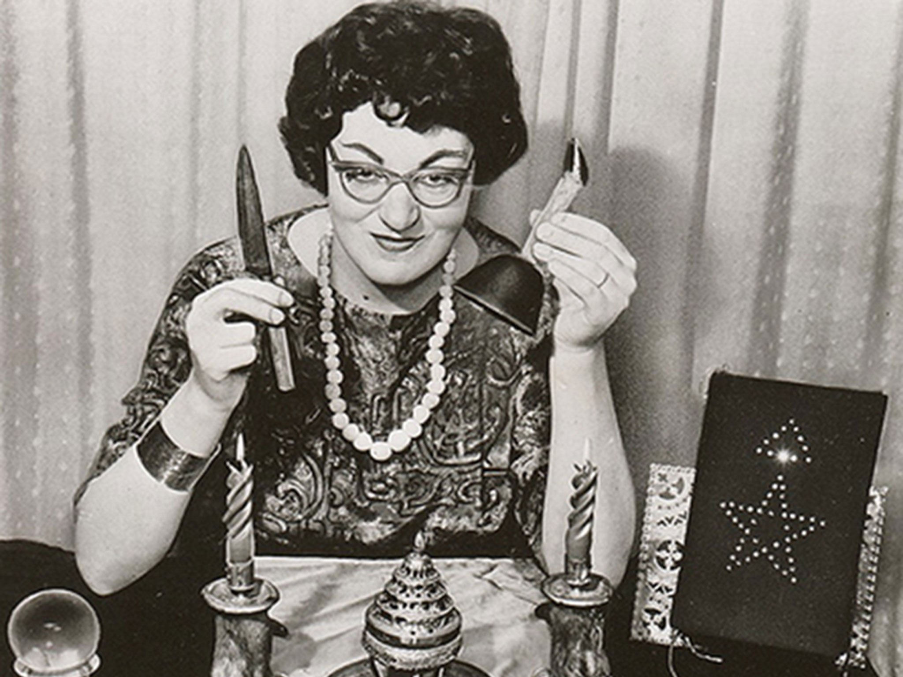
Now, If you can imagine that at this point, my enthusiasm went into overdrive – how incredibly amazing was this! At that time, there was really only a handful of known early Gardnerian initiates and it’s important to remember that this was in the days before the internet. So, naturally my younger self got really rather excited about such a connection!
It wasn’t long before I drove up to the west coast of Scotland with my Pagan boyfriend David Johnson, eager to meet up again with Iona and be introduced to John Upton.
I will always remember the first time I walked into John Upton’s externally, very normal looking council house to be met with wafts of incense and a huge, gaudy, mural of riotous colour that filled an entire wall. Oversized canvases of naked women, landscapes and flowers hung everywhere. There were hanging mobiles, dangling glass witch balls and a bit of a Moroccan theme going on with faded rugs scattered about. In the background, classical music was near constantly playing that is, when we weren’t watching Star Trek.
Here’s some pictures:

7 Upton House slides ending with phallus one (bear picture was 1968)
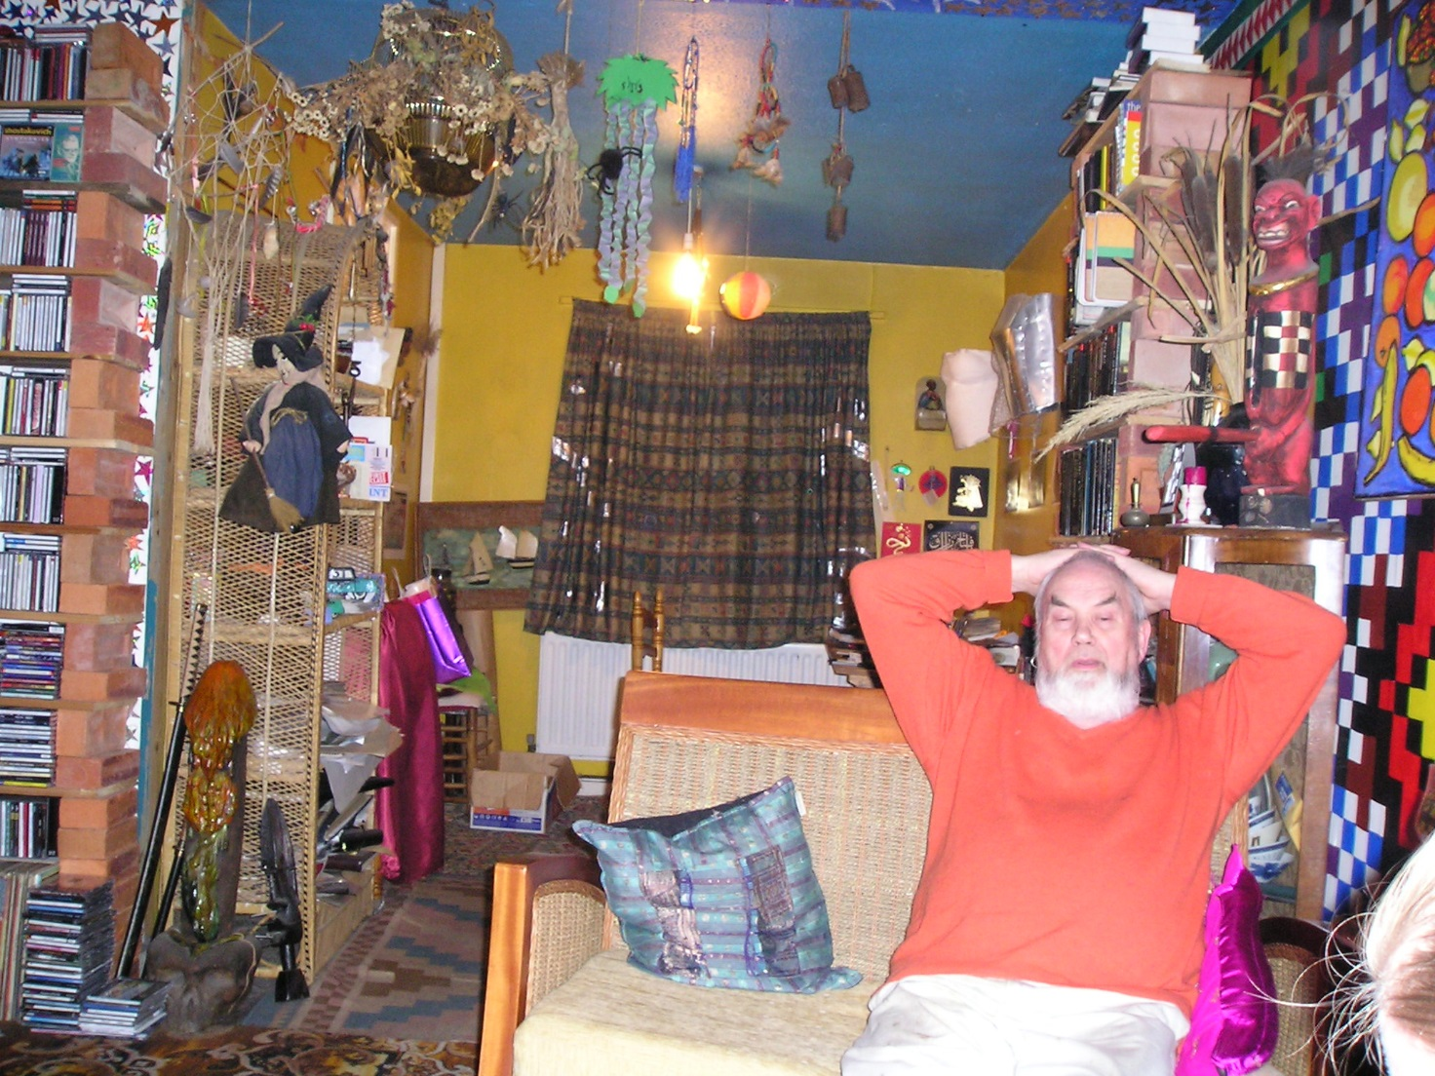
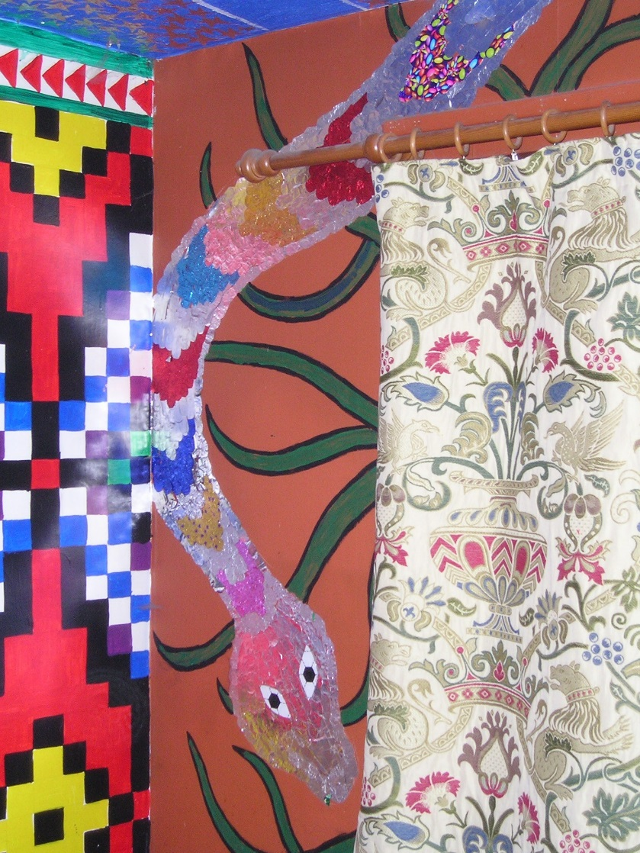
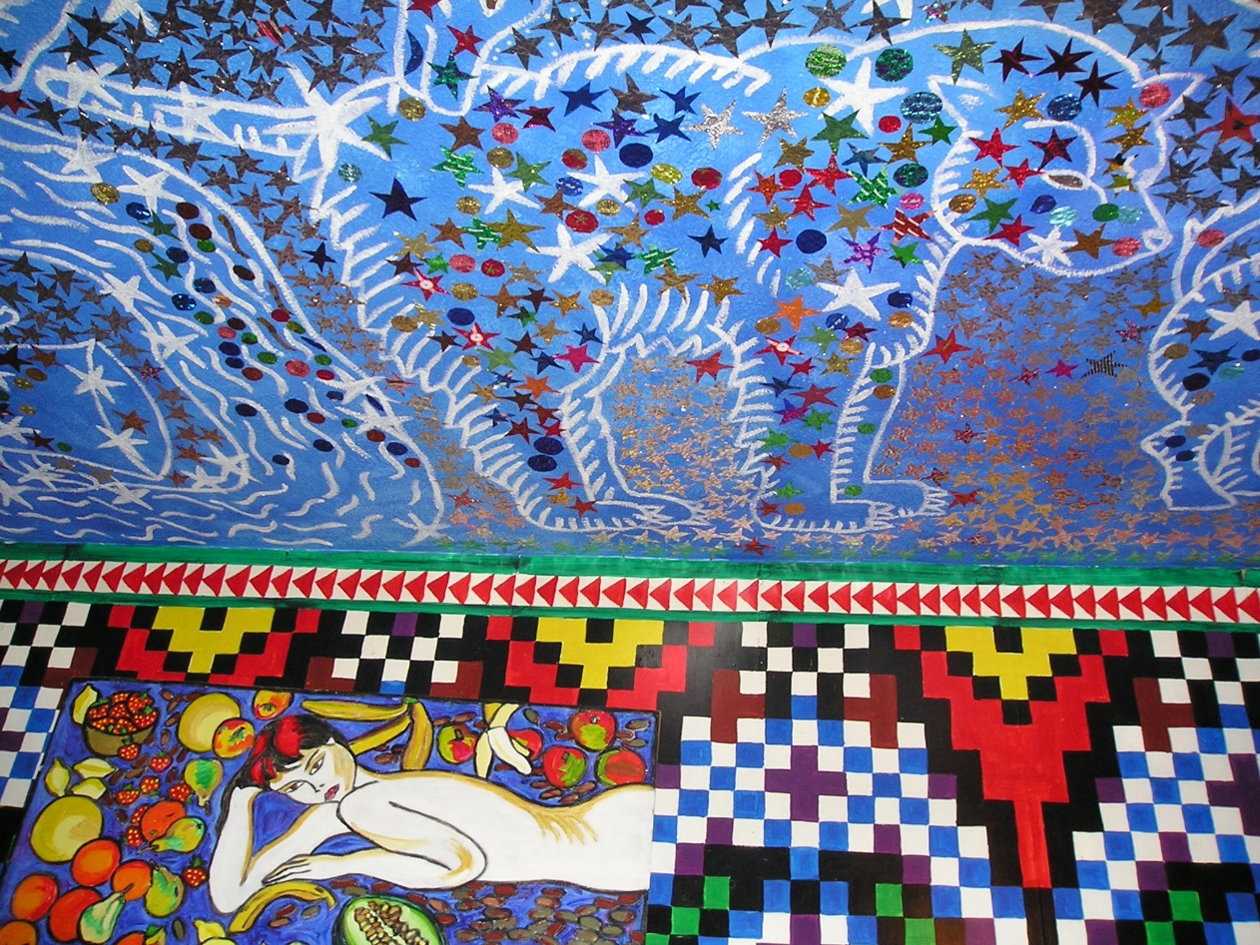

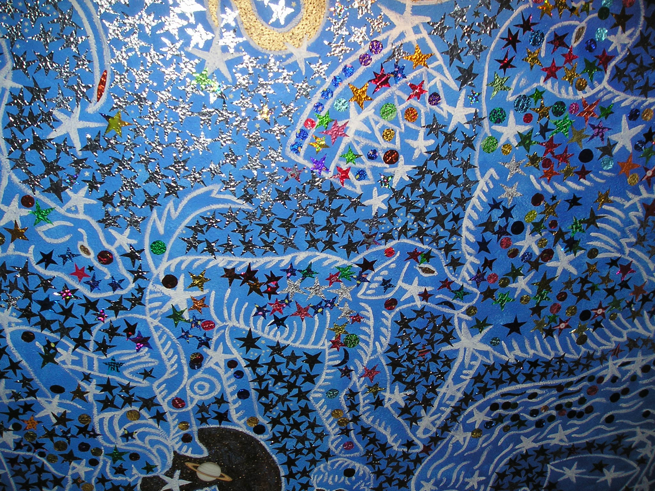
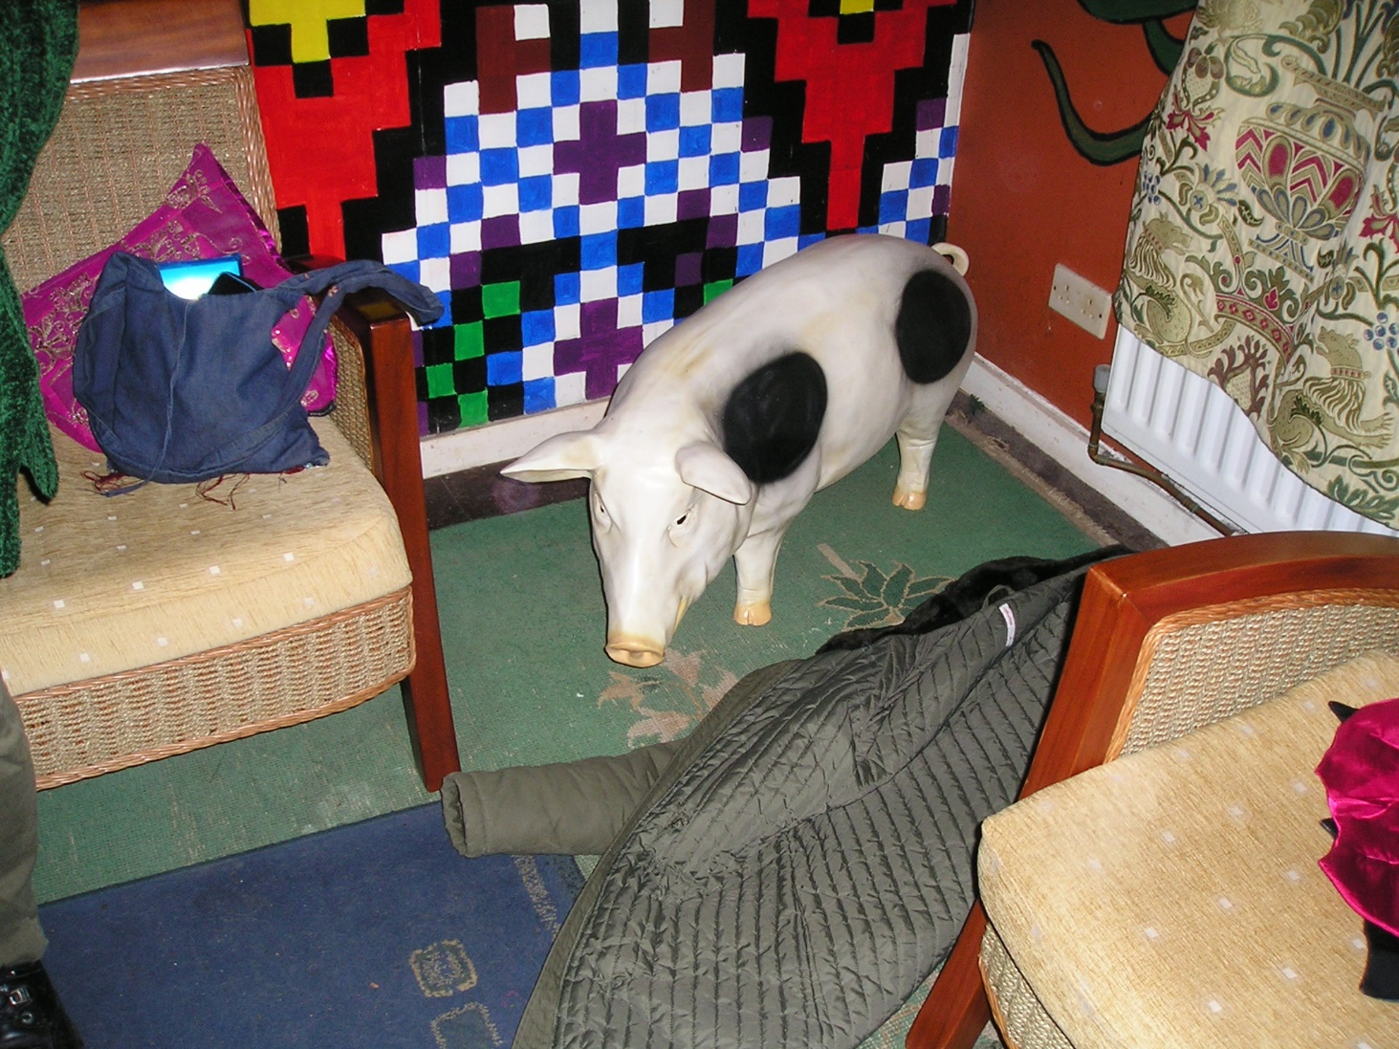
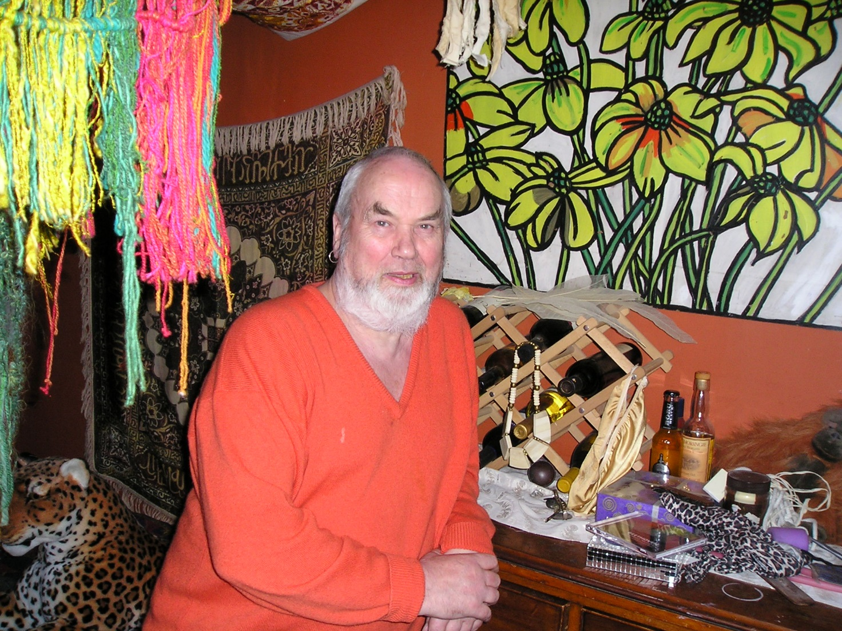

This object was particularly impressive to the young awakening self, a giant, maybe 5 foot tall, ceramic phallus with little winged doors on it – these opened up to reveal a foetus inside. This piece was given to John by the Brighton artist and sculptor Gary Turner – Interestingly enough, Gary was also the lead singer of the band ‘The Dodgems’ and had a hit with ‘Lord Lucan is missing’ in the late 70s.
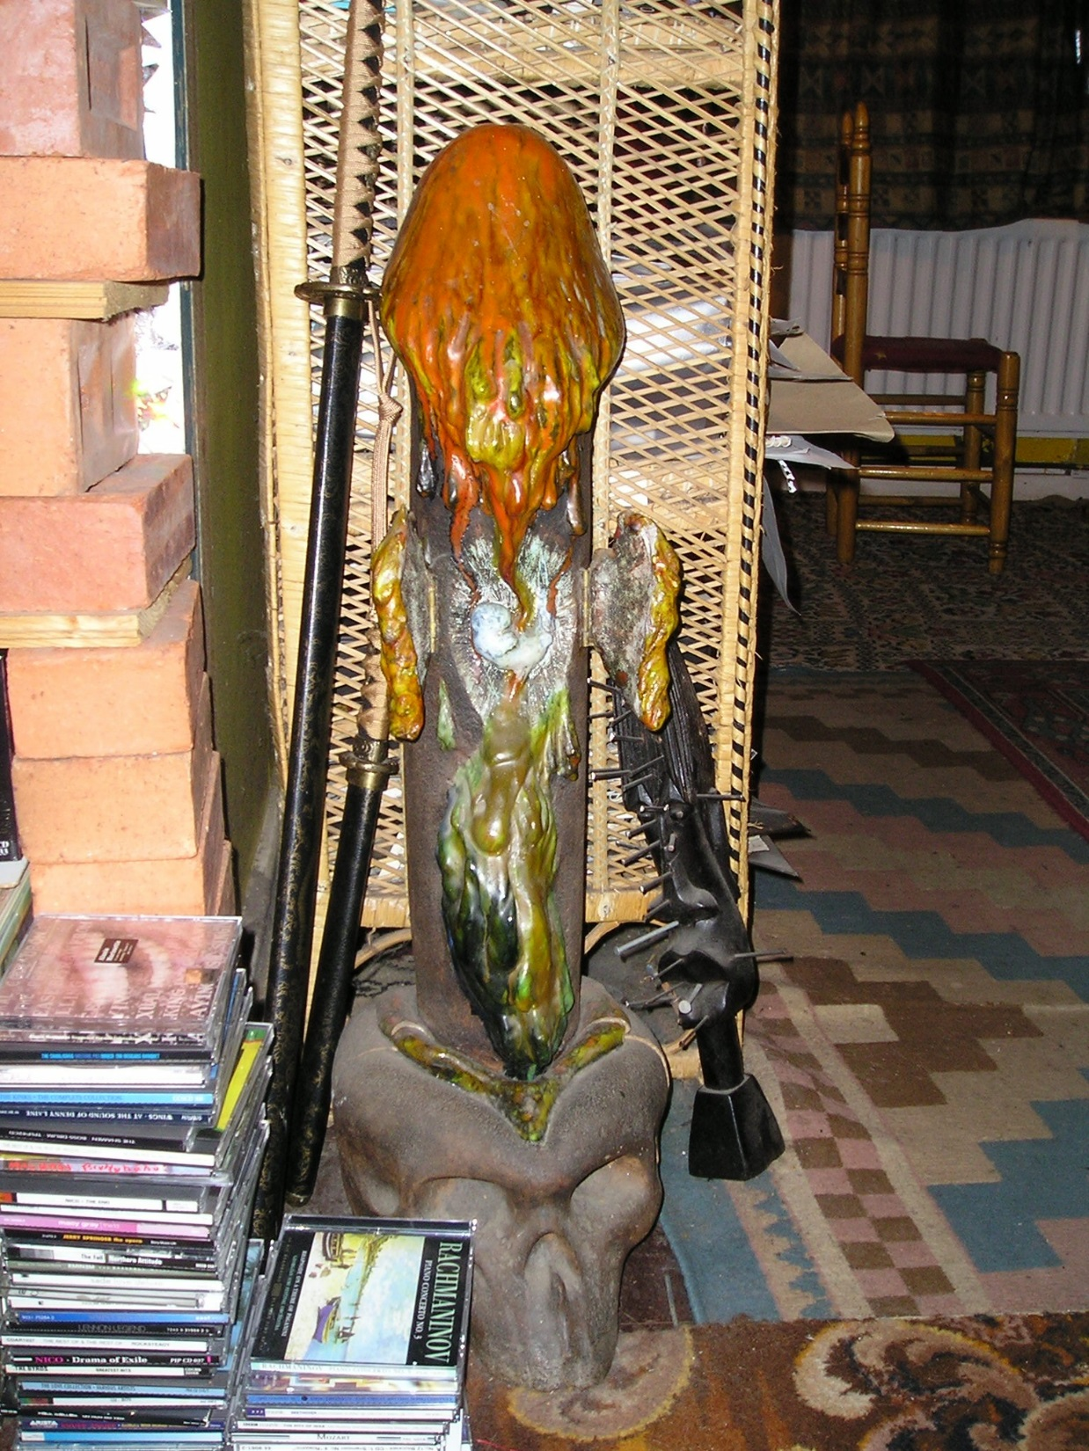
John Upton was born in 1933. He didn’t learn to read or write until his teens when a girlfriend taught him. As for art, one day, after seeing some popular paintings that he thought looked like they were made by children, he simply decided to be an artist. This rather unique background, left him completely unsullied by the artistic fashions of both academia and the contemporary art crowd, making him a true ‘outsider artist’.
Like any good Bohemian, John had a propensity to say things for good shock value and he would entertain me with tales of Brighton in the 60s and 70s where by then, he was the artist in residence at Sussex University and one of the local creative lynchpins. I was regaled with stories of psychedelic experiences, LSD trips, sexual experimentation, beatnik culture, Stiff records and the Brighton Unicorn bookshop.
Some pics:
5 slides of Brighton stuff starting off with Christs Entry into Brighton ending with bear suit
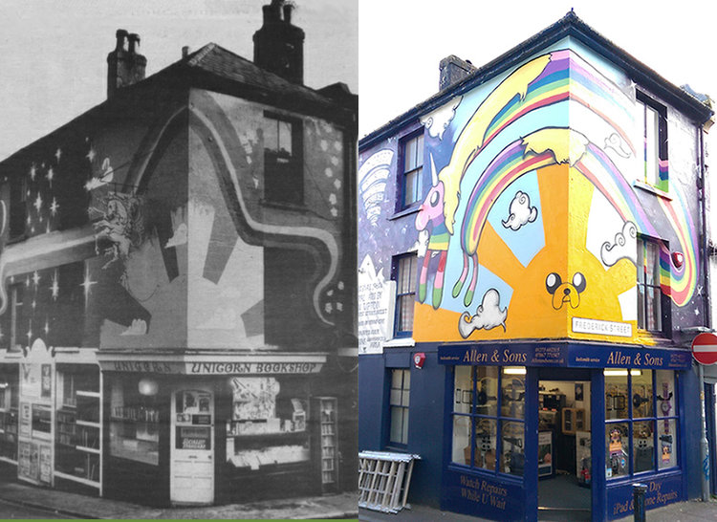
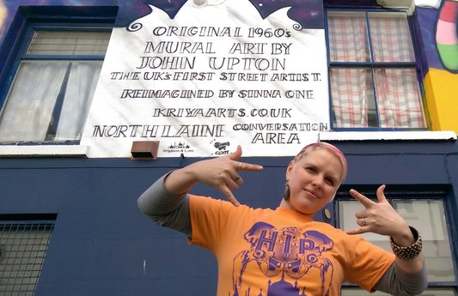
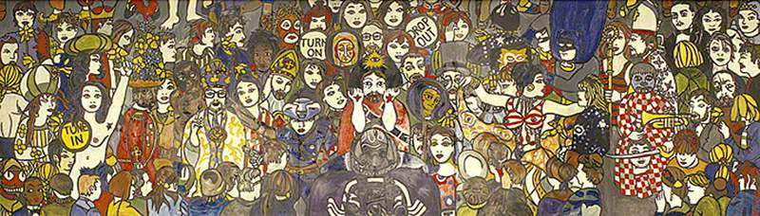
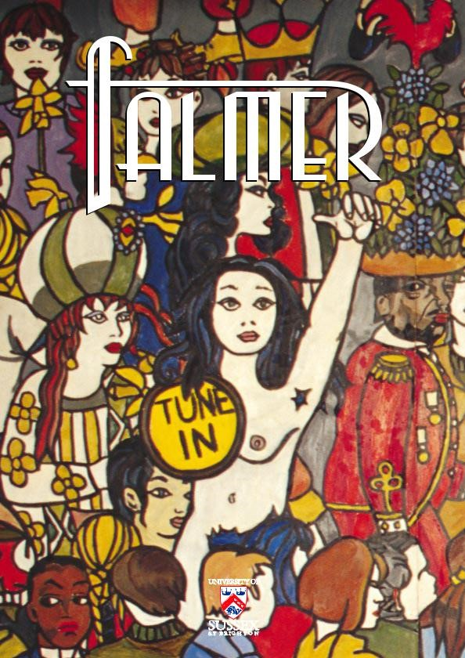
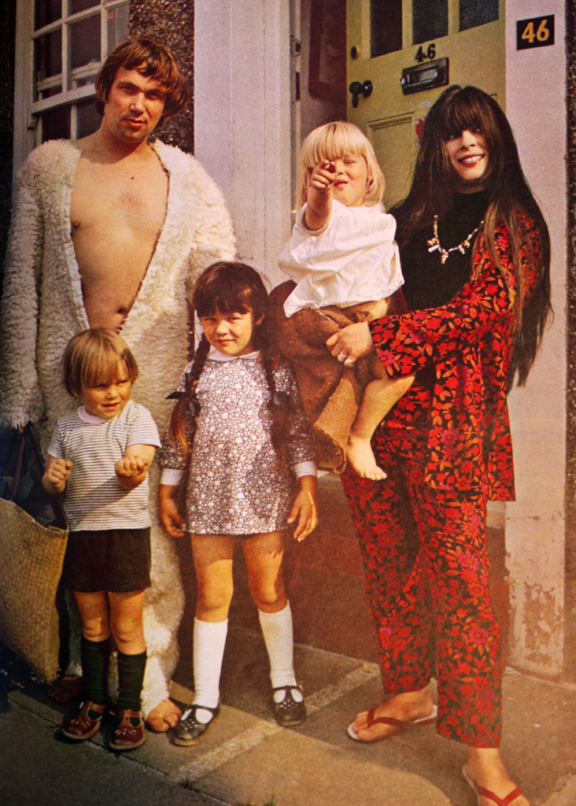
Given the seething hothouse of creative experimentation, a group of the more bohemian types from the University started to experiment with magic and theatre.
Picture of boho types. – woman on left Jackie Keen, wife of Jeff Keen an experimental film maker who had a Tate Modern Exhibition a few years ago after he passed away.
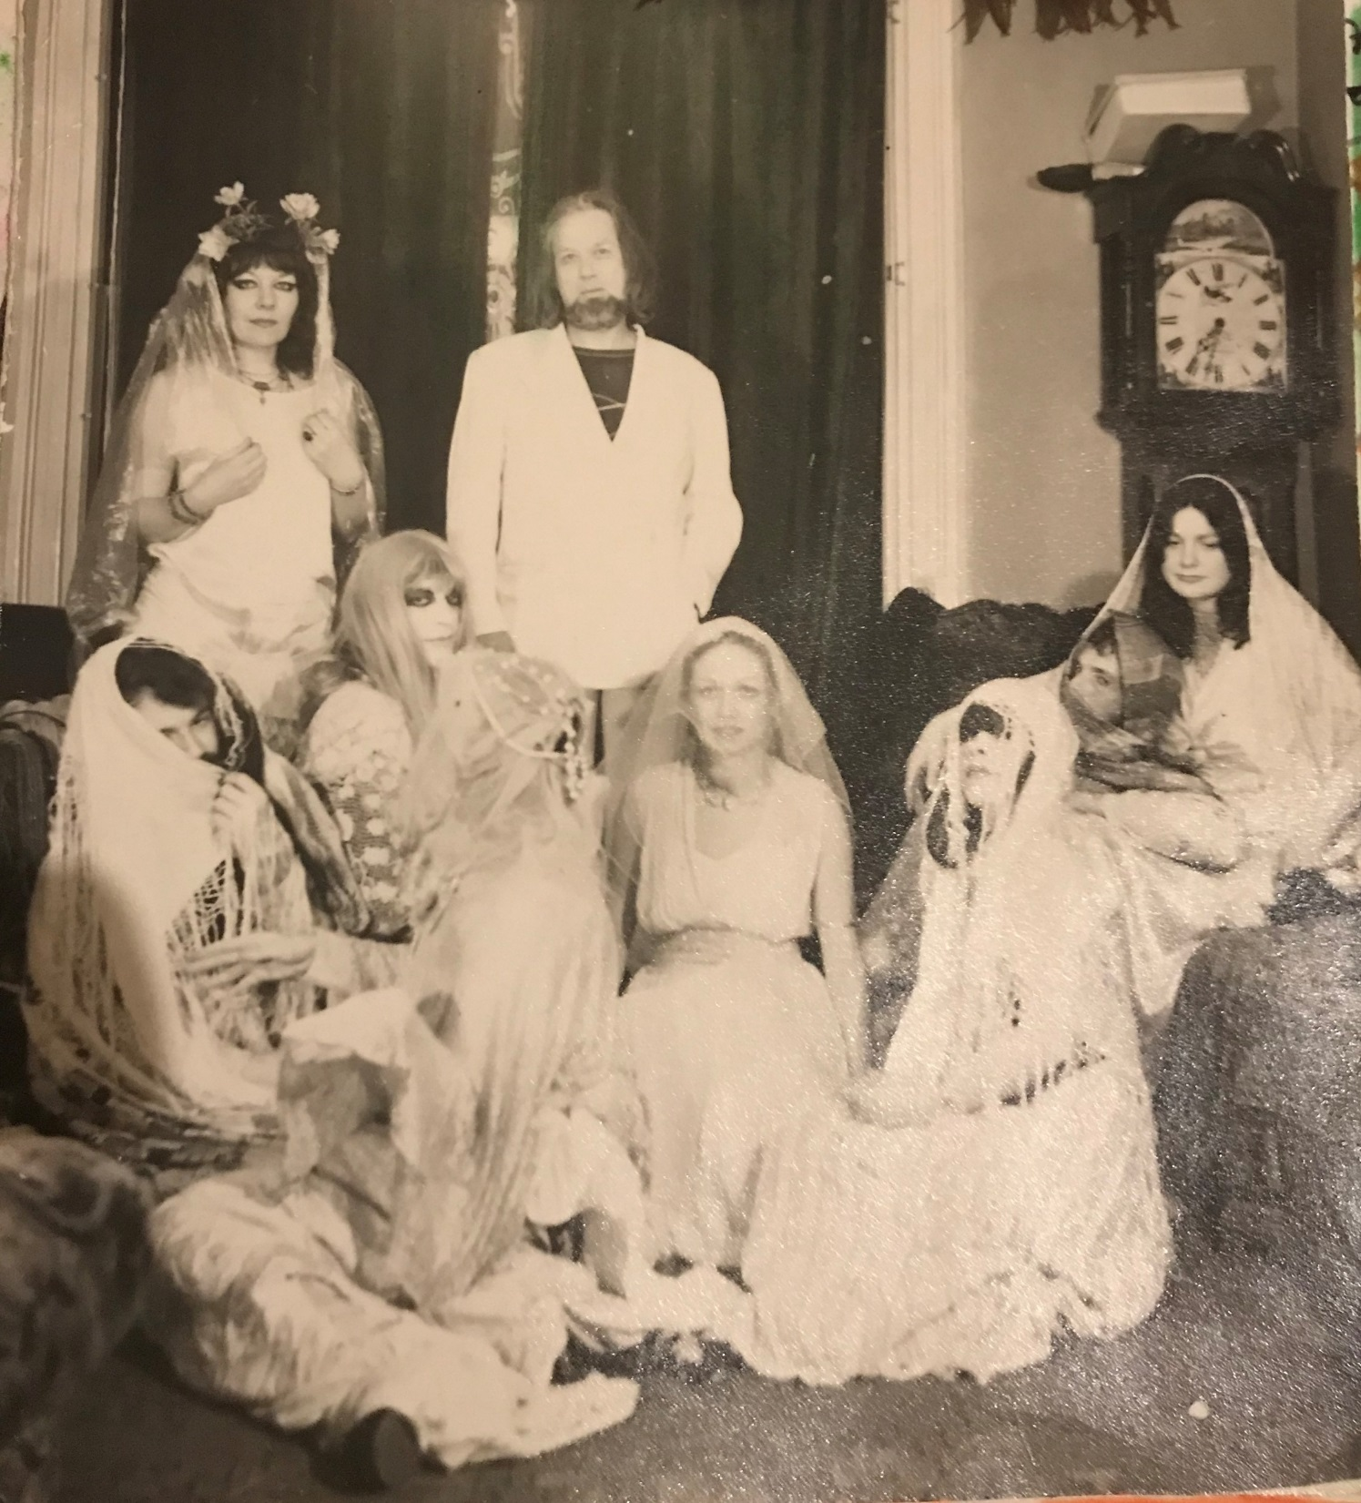
At this point, the highly inquisitive Doreen Valiente, with her natural interest in counter culture and alternative thinking, came along to this group and John told us that it was here, she initiated him and Gary Turner into the Craft whilst, perhaps a little oddly, playing Tibetan long horn temple music. Though actually, given this motley crew, perhaps that wasn’t so surprising!
Now, for any initiatory lineage pedants in the audience, I’m not saying that this would necessarily have been a ‘Gardnerian’ initiation though that is a debate I could happily have another time.
I have been fortunate enough to have had access to large chunks of Doreen’s scrapbooks and diaries and I spent a time transcribing them into a digital and thus more easily searchable form. By doing this, I can confidently tell you that Doreen was always questing for the truth behind modern Witchcraft and whether it had really survived anywhere in some small forgotten pockets of the UK.
For a while in the 1960s, she had worked with Roy Bowers/Robert Cochrane and his traditional Witchcraft – Clan of the Tubal Cain. She also went to great lengths to discover if Charles Cardell and his Coven of Atho had anything truly authentic behind them. So it’s not at all surprising that she would have attended this boho magical group on her own doorstep. It’s also important to understand that Doreen was far from a prolific initiator – this is a really important point given what was to come later in Johns life.
Skipping forwards now to the end of the 1970s, John Upton moved to Dreghorn in Ayrshire to become the nearby town of Irvine’s resident artist. He immediately started to be a ‘character’ with his innate bohemian Loki-ness. As an example, he organised a naked march through Irvine as a protest against the closure of a nearby nudist beach. (I’m afraid I haven’t got any pictures of that)
It was a few years later, in the 1980s , John was on a bus to Irvine and got chatting to a fellow passenger. An elderly gentlemen who, with time, revealed himself to have once been Gerald Gardner’s secretary, friend, initiate and for a while his right-hand man. This was Charles Clark.
Picture of Charles slide – apologies for crap picture – story of how I used to have a good one but put it in a safe place…
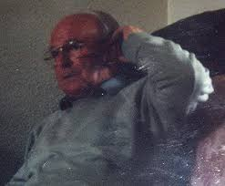
At that time, Charles Clark was a virtually unknown yet really important character in the history of modern witchcraft. You would find no reference to him in any published books aside from one, in Aidan Kellys 1991 book ‘Crafting The Art of Magic’ and that reference didn’t actually name Charles, referring to him instead, by the evocative title of ‘Mr Q’!
Just to give you a bit of background about Charles; he’d first met Gerald Gardner in the early 1950s at a club associated with the Isle of Man publication FATE. This described itself as the Journal of Fantastical Reality and covered things like Parapsychology, Witchcraft, and UFOlogy.
At that time, a ferry ran between the Isle of Man and Ardrossan on the west coast of Scotland, near to where Charles was then living. Gardner and Charles would often use this to visit each other.
Following the publication of Gardner’s 1954 book, Witchcraft Today, Gerald asked Charles if he could help him by answering the deluge of mail enquiries he was receiving from people all over the world, leaving Gardner to the running of his museum. He also commissioned Charles to head up the Scottish Wica (one c) and to form Covens in Scotland. In return, Gardner had promised Charles a future stake in the Isle of Man museum.
Charged with this mission, Charles went on to initiate various people, most notably, Monique and Scotty Wilson. Not long after, Charles started to regret that he had done this and wrote several pleading letters to Gardner highlighting his concerns about what he felt to be their character defects. But Gardner, ever swayed by a pretty lady appeared to have ignored Charles pleas and made an 11th hour change to his Will. Upon Gardner’s death, the museum ultimately went to Monique and Scotty Wilson.
I can tell you first-hand that Charles was deeply hurt by the whole incident and withdrew from a lot of the politics and involvement at the time but remained always true to the one ‘c’ Wica until his death in 2002
Jumping back now to the 1990s …So, there I was up in Scotland for the first time to meet John Upton, now, can you imagine my astonishment when he told me of this man, Charles Clark, who lived quite literally around the corner from him?! John casually said he would take us to meet him.
Charles lived in a very ordinary looking council bungalow. He was a warm man and was happy to invite us in and tell us his story.
We obviously looked a bit shocked perhaps even disbelieving, but then, in order to support his story, he started pulling old letters out of his drawers from people like Doreen Valiente, Patricia Crowther and L Ron Hubbard the founder of scientology to name but a few.
Picture of letters
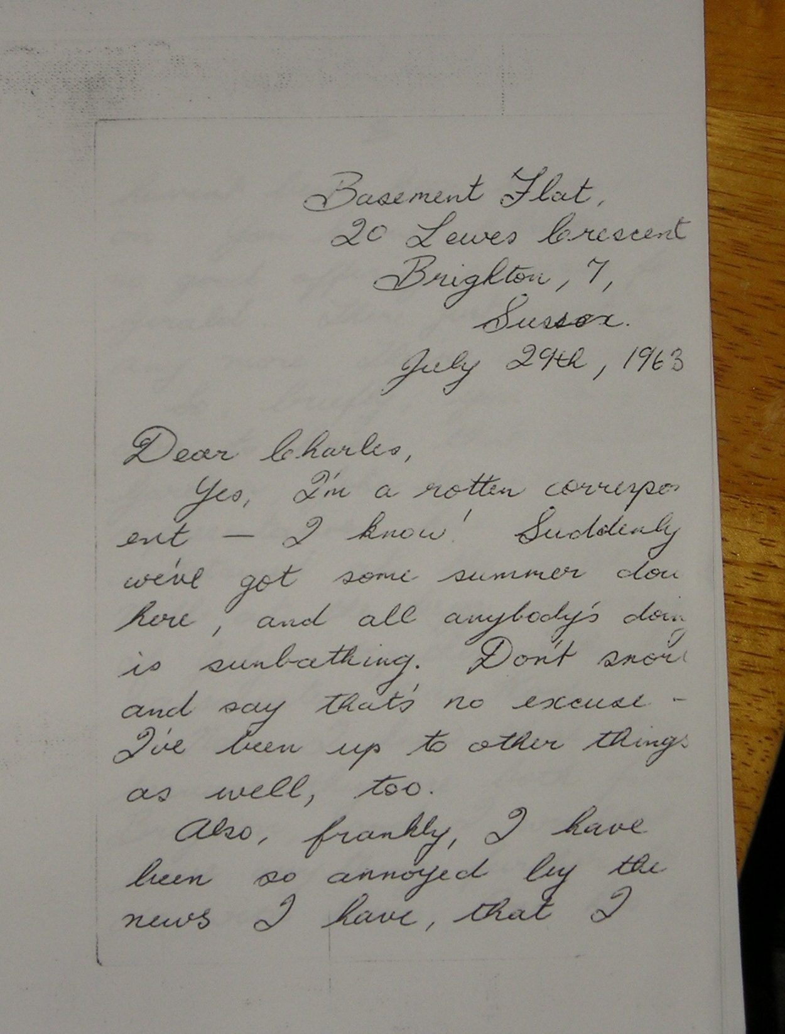
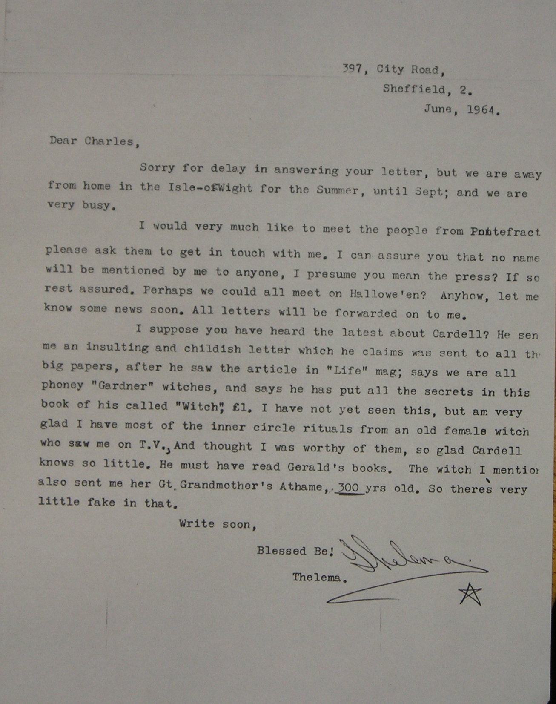
Anyway, we all went on to be initiated by Charles.
Let’s just stop here and think about this. John Upton, had known and had an initiation by Doreen Valiente in Brighton and then several years later, by complete coincidence he’d unknowingly moved to the same village and quite literally, around the corner from another very early Gardnerian initiate. If there was ever a strong argument to be had about magical lineages and egregores – this is a damn fine example of it.
John Upton, propelled by the epiphanous realisation of the totally amazing coincidence of all this, started thinking about magical threads and their tendrils through time. He consequently set about looking into the historical Scottish Witchcraft trails and creating his own Books of Shadows based upon them. You need to remember that this was in the pre-internet age, so John would be too-ing and fro-ing to the local library and ordering whatever books he could find about the trials and when the spirit so motivated him, he interpreted them artistically.
It is evident from the imagery and wording that John had pored over Pitcairn’s 1833 book Criminal Trials in Scotland wherein the confession of Isobel Gowdie takes up a mere 15 pages.
Picture 1 (here we see a picture of Gowdies witches transforming themselves into crows and stealing food) “when we will be in the shape of crows, we will be larger than ordinary crows and will sit on branches of trees. We witches went in the shape of rooks to Mr Robert Donaldsons house.”
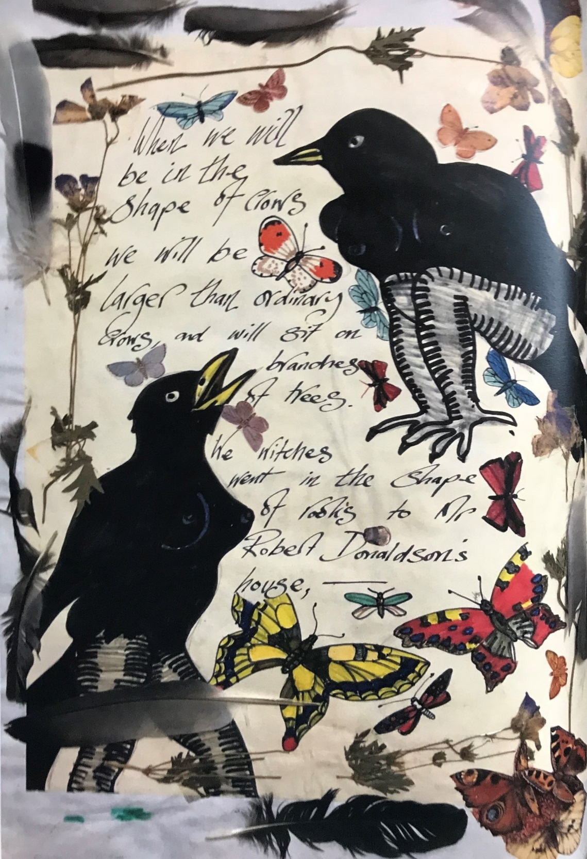
We also know that John read Brodie-Innes fictional book, The Devils Mistress, also based on Gowdies story, for John in some of his images, gives her hair that red appeal as imagined by Brodie-Innes.
Picture of Gowdie red hair
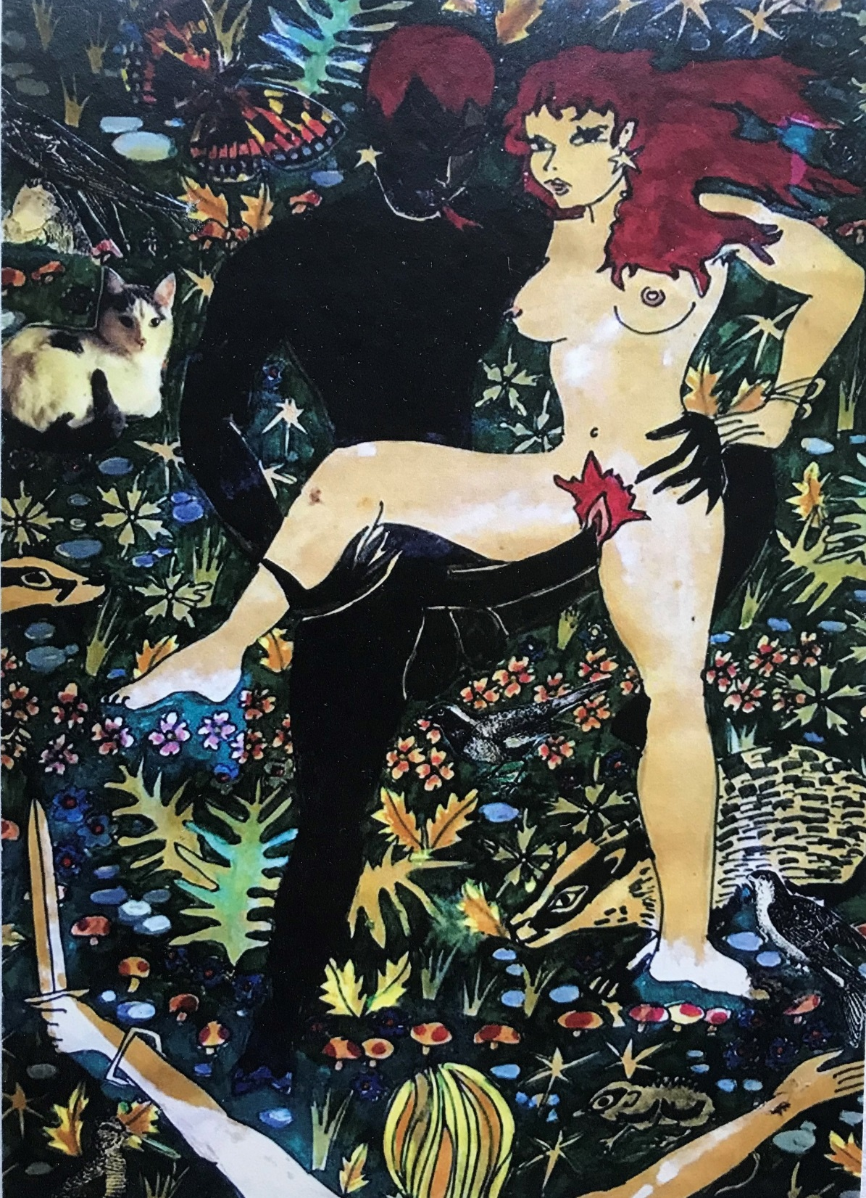
Another influence was Cruickshanks images of Gowdie, first printed in the 1830’s book ‘Notes on Witchcraft and Demonology’ by Sir Walter Scott.

2 Cruickshank comparison pictures.
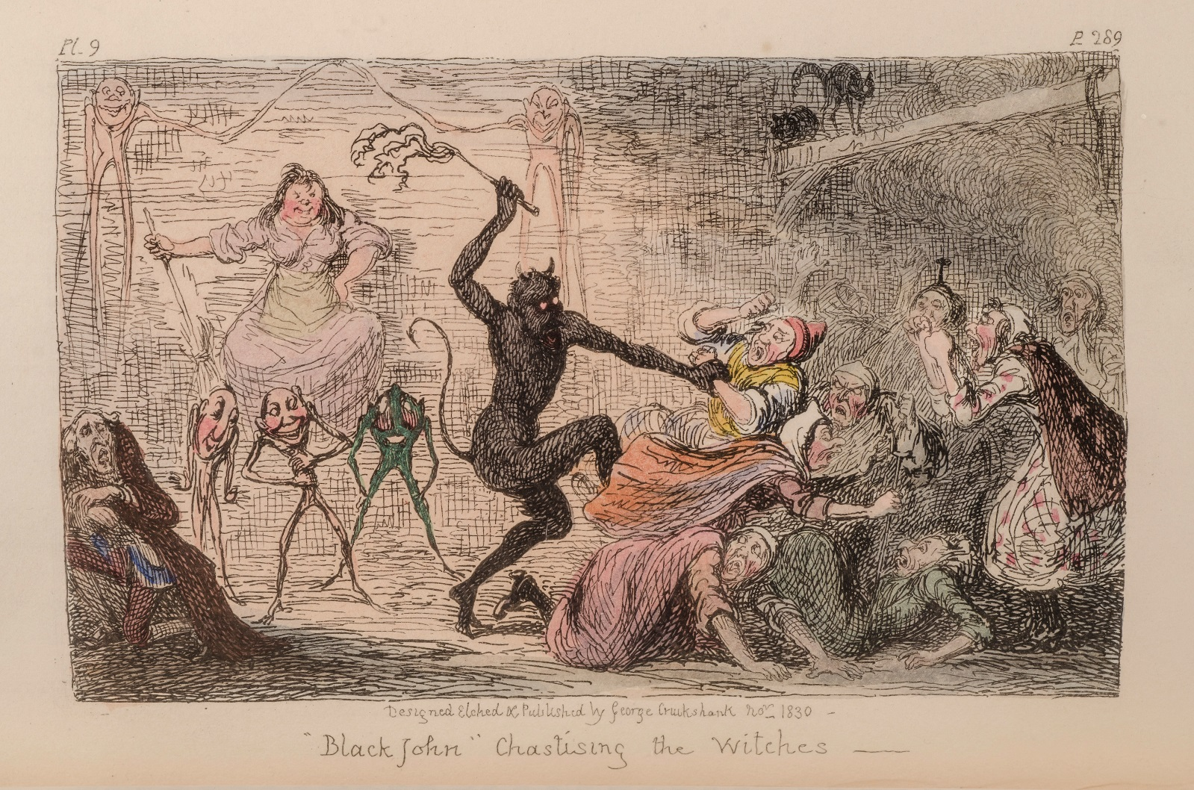
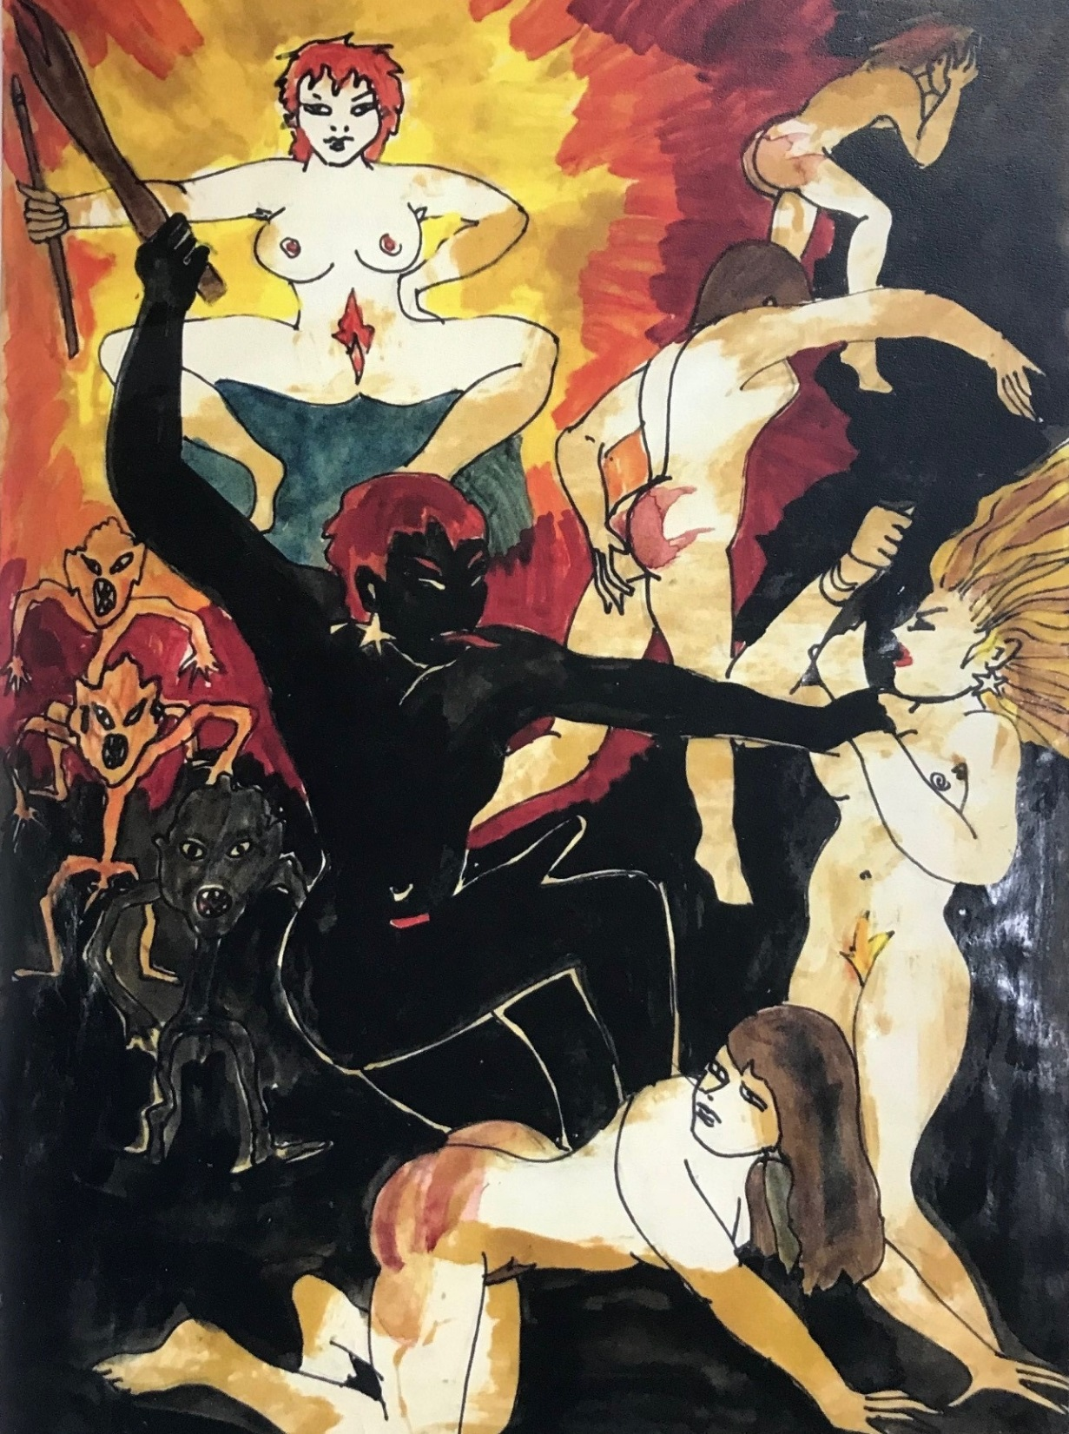

The work of Grien is also evident. It was Grien who defines the brutalised and sexualised image of Witchcraft in the West in the early 16th century where they are doing what witches do - raising storms, ruining crops and causing men to fall impotent.

Grien comparision
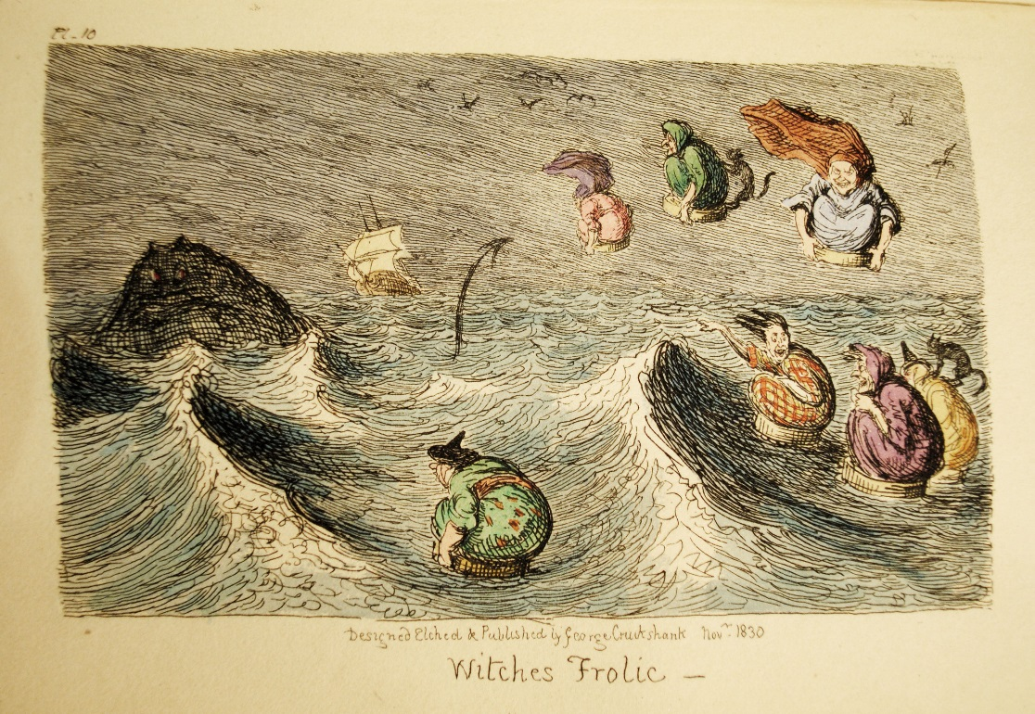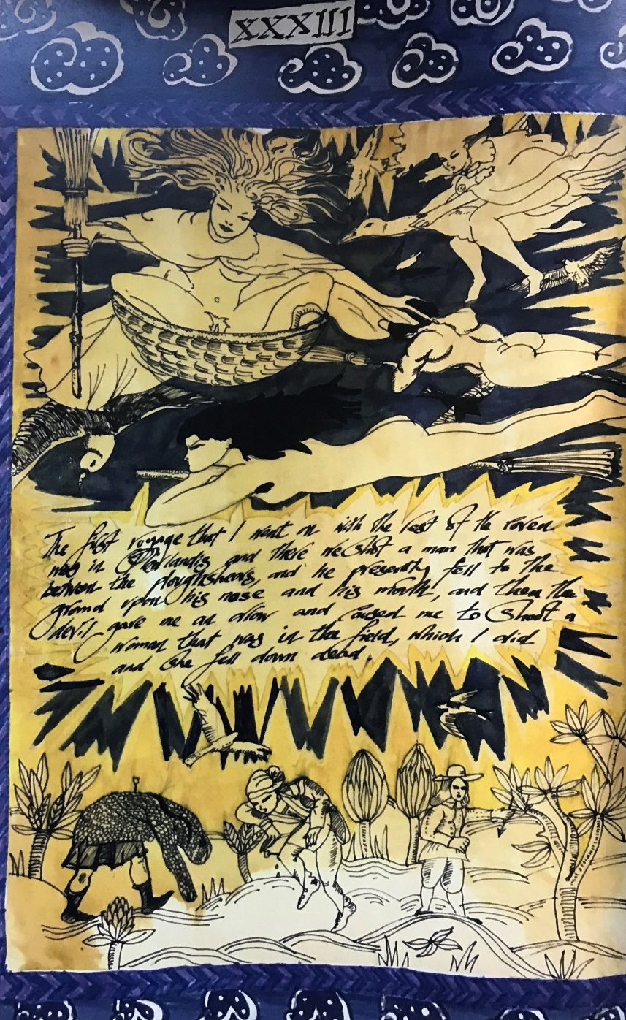

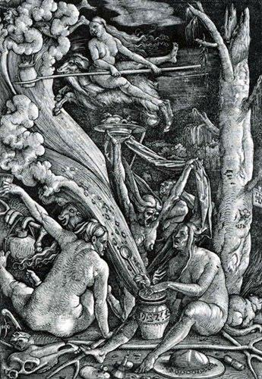
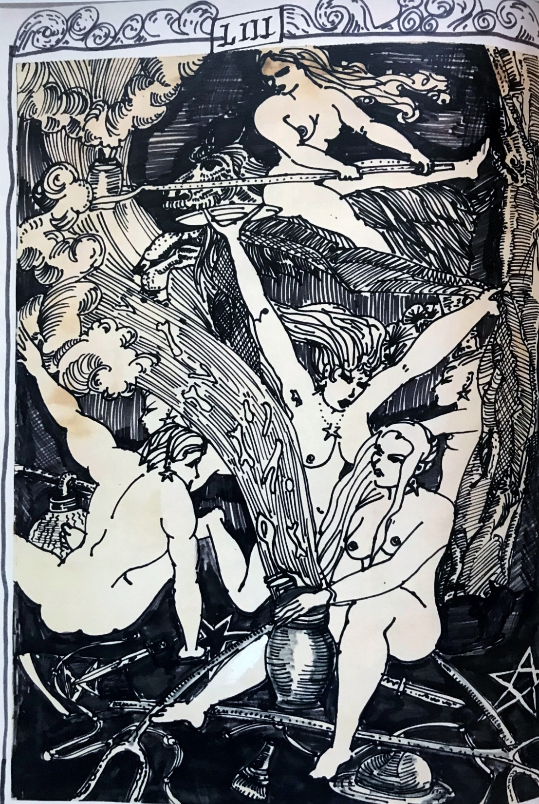
I also remember that throughout this time, John would often be listening to the James Macmillan opera ‘The Confessions of Isobel Gowdie.’ John, like any good witch bringing through something to manifestation, was completely immersing himself in her energy and her story.
Unlike Brodie-Innes and James Macmillan, John Upton does not seek to eroticise her possible death at the stake - something that he could easily have done for sensational effect – this is probably because her story, as revealed by her own words, was already loaded with a heady erotic content and needed little in the way of further embroidering.

Gowdie pictures
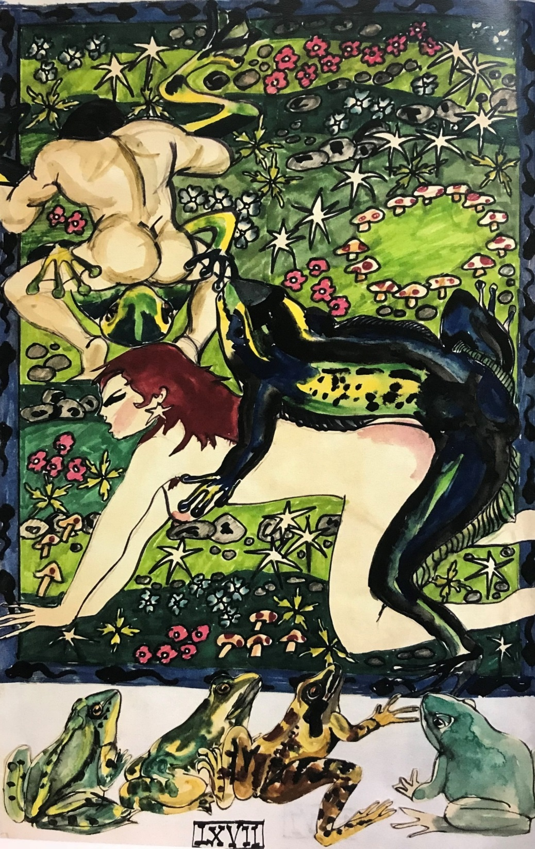
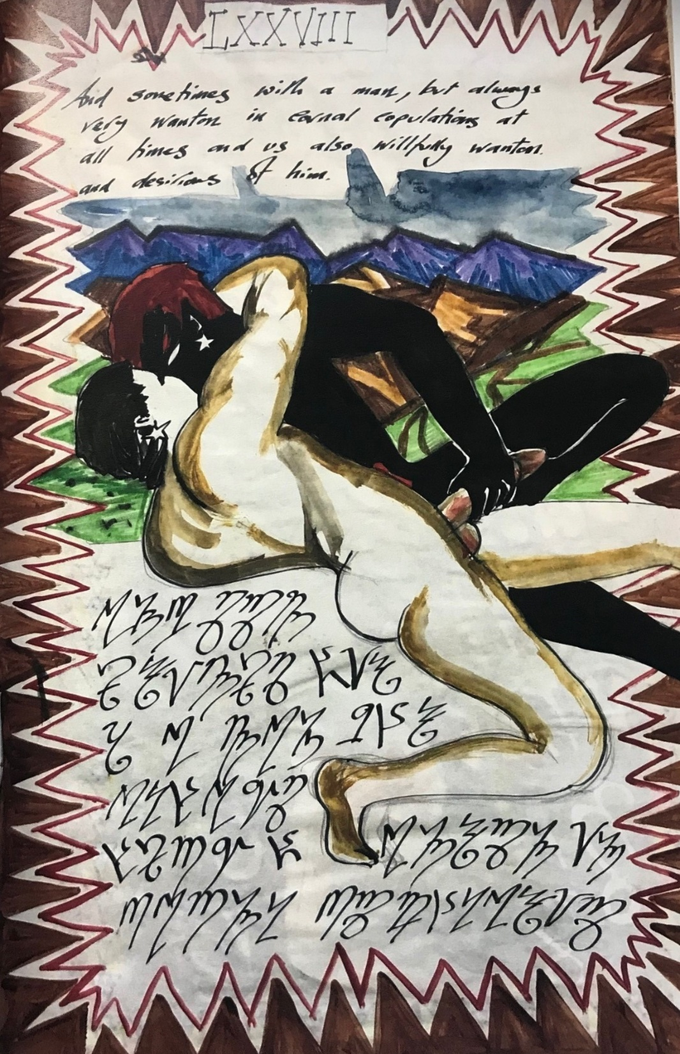

Now, I feel that the journey that this work took to being actually published, also needs to be mentioned for it too continues to whisper of a magical egregore, that continues to reach out its tendrils behind the scenes.
When John Upton died in 2005 he bequeathed me all of his artistic Books of Shadows. I bought them back with me to England, ever conscious that I had a special collection but with not the faintest idea what to do with them. Thinking I would probably just leave them to the Boscastle Witchcraft museum upon my own demise, they sat in a box in my garage for years.
It always niggled me that they were ‘hidden’ away like this, for they are the product of a truly intriguing set of circumstances.
I’m not someone who has much in the way of money and couldn’t even entertain the idea of fronting the cost of their publication. However, through a different set of highly fatalistic occurrences based on a geographical move that I had made to the middle of England, I had met and shown them to Eamonn Loughran, the owner of the Hellfire Book club, some years ago but clearly the timing was not right.
Then, last year, Eamonn approached me to ask if he could publish them. However we had a problem, we needed someone who really knew about the historical Scottish Witchcraft trials to write an introduction with me.
Two names came up and bizarrely and I think, as further clinching testament to the manifestation of magic in our real world, one person on the list lived, quite literally in the village next to mine less than two miles away from me, having moved there the year prior – John Callow.
I feel that this, is also really significant. I’m not saying that it wouldn’t have happened had he lived say 200 miles away, but it just makes it all the more effortless and easier.
The minute I found out that John Callow lived so close, make no mistake, I knew beyond any doubt that a published version of these books wanted to manifest and that it undoubtedly would happen – and now here they are 13 years later, amusing number not least because it was how many members that Gowdie claimed to have in her Coven.
Now, I’m sure you can appreciate that the creation and subsequent publication of John Uptons book, is rather an amazing story of spookily bizarre synchronicities and an excellent example, to quote Crowley, “A man who is doing his True Will has the inertia of the Universe to assist him” What he is saying here is that when your Will is in alignment, the Universe will naturally help you. Another quote that springs to mind if you are a fatalist is ‘Coincidences are fates way of showing you are on the right path’.
I’ve been involved with various magical ritual and pagan groups for over 25 years now and there is something to be said for knowing that you are on the right path and channelling your true, or some may call it Divine Will – it is when things effortlessly, just fall into place.
I think John Upton’s book is a beautiful example of outsider art and importantly, tell us that magic in symbolic and artistic form is just as or perhaps, even more powerful than chanting weird words, reciting Enochian, waving magical tools in the air, or circumambulating around a temple.
The inherent power of John Upton’s life and indeed, this book, embodies a true and potent magic akin to Isobel Gowdies visions with them both creating a rich story that continues to captivate and move us all.

John Upton Slide
